Cross Cultural Perspectives of Tourism Portfolio
{RTM 404}

11/13/2014
Portfolio Project
Karissa Duda

Section # 1: PBS Untold Stories
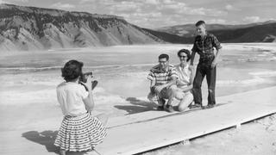
- African American tourists comprise less than one percent of the visitation to Yosemite National Park as told by the PBS Untold Stories. Shelton Johnson, an African American park ranger has made it his life’s work to connect the African American population with national parks. There are numerous ways that could draw the African American population in to national parks as a tourism destination. I think that educating the school systems, like Shelton has been doing is a positive way to bring the ideas up to children. If Shelton built a team of people to help him travel and speak with students I think it would be beneficial to reach a bigger audience. He could include pictures, history, stories etc. in his stories to make it appealing. I think the history is important to tell. Kids especially, relate through stories and experiences. When Shelton Johnson brings his story to life by portraying a real name in the Buffalo Soldier times, he is building character and an interested audience I assume. I think they would love to hear about the soldiers and how they lived and how they were treated. In relation to Gerard Baker’s story on Mount Rushmore, Shelton Johnson could put on a show when people come to the park. He can bring the culture of the Buffalo Soldiers alive, and create an even more interactive experience besides just talking and explaining. There is something spectacular about a virtual experience, so if an African American family was immersed in a type of camping trip with the cultural aspect to it, this would add some interest possibly. They can utilize the acorn trees, horses, food, soldier costumes, and have fun with it! Gerard Baker said in his story that he put up a teepee and it instantly became a hot spot to be when visiting Mount Rushmore.
- The inclusion of American Indian history and culture at the Mount Rushmore National Memorial seems to be a positive aspect for Mount Rushmore Memorial. I agree with the statement that Gerard Baker makes. He says, “The ultimate goal would be to have kids tell their parents they want to go to a national park. This could lead to people talking more about who they are and maybe in the future who they’re going to be.” I believe this statement is significant because of culture in general. The Black Hills at Mount Rushmore is sacred land to Native Americans, and remembering history and the past and what has happened could be a great lesson to all. It also is a story, and will open up the opportunity for others to tell their stories. I think teaching the Native American culture through the teepee, the dances, and symbols have a positive impact on history. As long as the history being decoded is real and has a lesson, then it is valid to show and tell. I think it is important to see different sides of history. In this particular case, there is the American side as well as the Native American side. The reasoning for carving the presidents in the mountain was so that people can remember our freedom and our democracy and what we stand for. At the same time, it is a reminder of the Native American’s lost land in 1876. Sharing the different victories and down falls of society through history is an experience that Baker has started to create. The Sioux culture is exposed in “Heritage Village” there and people are interested and listening, so continuing with the learning seems to be something they should continue there. Baker is the first Native American Superintendent of Mount Rushmore and wishes for everyone to take pride in their culture. In all, I think there needs to be an emphasis on the positive and negative aspects of war, the Black Hills, and the cultures surrounding this era. Everyone can learn something.
- Our country needs to balance our citizens’ civil liberties as well as deal with the need for national security. In an incident like Manzanar, we see how an entire people were brought to camps where they were dealt with like slaves. We need to make sure this does not happen again. America made a huge mistake. If you relate a situation like 9/11 to our civil liberty and national security, then there will be debate. I believe that setting up a high security system so that terrorist attacks cannot occur easily is in the best interest of all Americans and travelers. I think that there is a line we have to draw. In the Manzanar case, we flat out disregarded the fact that Japanese-Americans grew up in America and did nothing to deserve the confinement. Pearl Harbor was bombed by Japan, not Japanese-Americans. It is important to learn from past mistakes, so taking this situation and giving it the attention it deserved and apologizing was a move in the right direction. We also have a national site to honor a difficult period. We have acknowledged the wrong doing and the pain it caused the Japanese that were locked up at Mazanar. We can mourn the incident and learn from it and move on to a better society. Tourists should learn the hardship and the tragedy that happened when they visit Mazanar. Our entire society has to stand up for what they believe in. We can make something happen if we stand up as a nation. We are free, we have a democracy, and we should use our rights. We have dealt with disaster, but it is also valid to keep in mind that there could have been preventative measures set in stone before something bad occurs. For example, even if a natural disaster such as an earthquake struck California, we would not even know where to go or what to do. There should be more developed plans. If you look at security on a national level, we have a lot of airplane security. We also have border patrol and highway control and levels of security to keep people safe. I think with technological advances, we are more aware as to what is coming. We can continue training security to protect our nation but within the rights of individuals.
Section 2: Codes of Cultural Behavior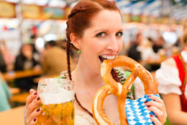
My Choice of a Country
I choose Germany for my studies on cultural behavior. I chose Germany because I have always wanted to visit. I find the people that I have met from Germany to be extremely nice and happy. I ended up having a German roommate who was studying abroad for a semester. She was the best roommate I could ever ask for and I still keep in touch with her. I always tell her that I will visit her, so here is my chance to get to know the country better. My friend Marina told me many differences from here and there. I cannot wait to find out even more! Also, my dad told me that the beer is excellent in Germany and that my mom and he had an amazing time when they went and traveled in Europe. I want to experience a different culture that takes public transportation, has a different drinking age, has a different schooling system, and has different food laws even. I know I will find all these in the country of Germany. I hope to have a great experience when I finally get to travel to Germany. For now, I get to dig deeper into research on the culture Do’s and Don’ts of Germany.
Brief Cultural Overview
Germany has a long history of triumph and separation. Dating from ancient times, the struggle has brought Germany to a current state of unification. German history is said to date back to 113 BC when Germanic tribes were forced away from Roman lands. Julius Caesar ruled during the Roman period and he did not get along with the chief, Ariovistus. Caesar kept fighting different tribes out of their lands which eventually led to the end of the Roman Empire. (Germany: History to 1519) In the fifth century CE, Charlemagne ruled under Christianity and when he died he left a Holy Roman Empire. This was year 1356 now, a time when princes were elected emperor and turned the empire into a monopoly. Fast forwarding many years to 1517 when Martin Luther King wrote the 97 Theses and posted them on the church of Wittenburg’s door. This caused a huge stir up because of the clash against the teachings of Catholicism. This was the beginning of the separation of religions in Germany as well as the beginning of the 30 year war of killings, disease, and famine. In the 18th and 19th centuries, Napoleon helped end the Holy Roman Empire. In 1818 the no Austrians allowed period began. We all know about Hitler and his revolution to get rid of all Jews. They experienced a great loss and much separation of states, but presently, “…they are the most powerful country in Europe.” (Let’s Go Europe 2014)
When you travel to Germany there are many languages and religions that are taught. The most prominent language, at 95% of the country’s population is German, and then all students are forced to take English as well. (BBC News) This is convenient when traveling because almost all Germans know some English. Under German there is high and low German that is spoken by Indo-European cultures. The splash of immigrants in to Germany brought Turkish, Polish, Greek, Italian, Spanish, Portuguese, Mongolian, Serbo-Croatian, and Vietnamese. As stated in the previous paragraph, Germany was and Catholic. Today, the vast majority follow Christianity. Other religions include Lutheran, Evangelical, Calvinism, and Jewish. (Countries and Their Cultures) As you can see, Germany is comprised of many languages and religions.
Codes of Cultural Behavior
To ensure you are traveling safely and respecting the culture you are traveling to, abiding by the Do’s and Don’ts are pertinent to your travels. A Germany essential under money includes tipping. The people of Germany do not expect tips but when you experience great service in Germany, you should tip. A service charge is added to your bill when dining at restaurants, but it is customary to add a tip of five to ten percent. Housekeepers, bellhops, public attendants, and luggage carriers should all get a tip as well. This is also a custom in America, but even less of a tip, so it should not be too hard to handle and remember. Keep in mind that it is cheaper to travel in many cities in Germany when compared to other surrounding countries. Food and travel costs are a lot more affordable to a traveler here. Do take public transportation and do not bother with a taxi. (USA Today) Another Germany essential is to abide by safety and health policies. Laws are taken serious, and if you think you can get out of a fine, you are wrong. Jaywalking alone is a five Euro fine. The drinking age is a lot younger than America, so as long as you are 16 for beer and wine and then 18 years of age for spirits, you’re good to go. Also, under laws and regulations, make sure to bring Sudafed or Benadryl if you need, because in Germany you need a prescription for these. (Let’s Go Europe) When traveling to a restaurant, seat yourself and do sit next to strangers. This is normal and friendly to do so. This will help you get to know the people of the area. Also, do not put your elbows on the table. This is rude in their culture. You can however put your hands on the table, as long as you are not picking up food with your hands. (Travel Taboo) Under customs and Etiquette, Do specify if you want tap water, or else they will rack up your bill by handing you more expensive bottled water. Other sources say don’t order tap water because it means you are stingy. Do try beer, but do not act like a stupid drunk. They would rather you be a happy drinker than a crazy drinker. (Travel Taboo) Don’t assume that bread is free, because more often than not, you will have to pay for bread. If you are invited to a German home, bring chocolate or flowers. This is a sign of thankfulness. Don’t just choose any flowers, because many flower kinds have a stigma associated with them. A safe flower to choose is yellow roses or tea roses. It is important to address your elders by their title until further directed, as well as shake hands with every single person you meet, including children. When you enter a home or store, it is customary to say hello and goodbye, “Guten Tag” and “auf Wiederseheb”. (Let’s Go Europe) Do not ever say “Hail Hitler” or show signs of swastikas of any kind. You can be arrested and get a criminal offence. The Germans are sensitive to their past and do not believe it is polite. It is not tolerated. When bathing or going to the beach, nudity is the norm. There are signs marking that the area promotes free body culture. Kids and adults alike are use to this, so it is nothing to be ashamed of. I learned that you should always carry cash with you. Do not use a credit card because many places in Germany do not even take a credit card. Lastly, do not be late to an appointment or meeting. Tardiness is not tolerated. Germans expect you to be on time and ready to talk. They do not like idle-chat either, so having something to speak about is nice. They are known as friendly people, so do not worry, just enjoy yourself. (Travel Taboo)
Unusual Aspects of Culture
I am not really worried about the Do’s and Don’t of traveling in Germany. If anything, it makes me more excited. I think it is really cool how young you can be to drink alcohol in Germany. I think that the USA would actually be better off with a lower drinking age. However, they have a way lower tolerance for drinking and driving, so just taking public transportation is your best bet. I think I need to experience some real public transportation. I think it is really cool how many people speak English in Germany. It makes me less nervous to travel there. I find it unusual that a particular flower is so prominent in their cultures. Here in America, we pick up a flower and as long as it looks pretty and smells good, we are happy. In Germany there are too many flowers that mean different things. There are flowers for funerals and there are flowers for a simple hello when invited to a dinner. I find it unusual that nudity is so nonchalant in the country as well. I would feel uncomfortable going to a beach like that, but in Germany it is very normal. Another aspect I was surprised about is that we are supposed to use cash primarily. I usually carry around cash but I feel like it is easier to carry around a card, but for some reason Germany does not use credit card machines like we do in the USA. I’m also surprised that bread is not customary when in a restaurant, as well as tap water is known as cheap. I’m happy to know this in advance because I would be committing a crime against some basic rules in Germany.
When reading about the history of Germany I found it interesting that it is still shameful to speak of Hitler in the country of Germany. In fact, you are committing a crime. In doing some research on places to visit in Germany, I came across the Jewish Museum in Berlin. The museum reminds us of Germany’s past and the 6 million Jews that were exterminated. There were many items that were dug up and put on display in the museum that were destroyed previously by Hitler and his army. The museum was designed to make the viewer feel uneasy and unwelcome to get a sense of what Jews went through in the late 1930’s. (500 Places) The reflection would be one to remember and visit, one that would tell some history of Germany. I do think it is important to visit museums and art galleries to see their past and learn more of the cultures. Overall, it would beneficial to me to visit a city in Germany that has come so far. I would love to see how a country that went through one of the toughest wars in history can get back on their feet and be so positively powerful now.
On a positive note, I would be extremely excited to try one of the 5000 beers that are brewed in one of the 1300 breweries in Germany. (Eupedia) I would love to visit the world’s oldest brewery dating back to 1040 that is in the city of Freising. I cannot help but to think about experiencing the country of Germany with my 19 year old brother and sharing a beer with him. Now that would be awesome!
References
Germany: History to 1519. (2014). In The Hutchinson unabridged encyclopedia with atlas and weather guide. Retrieved from http://libproxy.sdsu.edu/login?url=http://search.credoreference.com.libproxy.sdsu.edu/content/entry/heliconhe/germany_history_to_1519/0
Let’s Go Europe 2014, The Student Travel Guide.
BBC Homepage. http://www.bbc.co.uk/languages/european_languages/countries/germany.shtml
EIDSON, JOHN. "Germany." Countries and Their Cultures. Ed. Carol R. Ember and Melvin Ember. Vol. 2. New York: Macmillan Reference USA, 2001. 847-865. Gale Virtual Reference Library. Web. 12 Nov. 2014.
http://www.traveltaboo.com/germany-travel-tips-dos-and-donts/
USA Today
http://traveltips.usatoday.com/things-traveling-germany-105986.html
500 Places to take your kids before they grow up. A Frommer’s Book. 2nd Edition. (pg 237-238).
http://www.eupedia.com/germany/trivia.shtml
Section #3: Mountains Beyond Mountains Essays
Application of the W Curve of Cultural Change
- In his first year in Haiti, Paul Farmer reflected on a young doctor who was anxious to return to the United States. Farmer revealed, “I wasn’t feeling judgmental. Haiti was something he was seeing that he could leave and erase from his mind, and I was thinking, Could I do that? He was leaving Haiti, really leaving in body and mind, and I realized I was going to have trouble with that.” Relate this to the “W Curve of Cultural Change, Adaptation and Adjustment” discussed in class. In addition, explain the obligation you feel we have, if any, to other places we see—even though we return home.
When you are leaving for a trip, or just arriving, you are in the honeymoon stage. The young doctor that Farmer described was feeling anxious to leave and get back to the United States. This is when he is at his low point of enjoyment stage and kind of in a stage of disappointment during the trip. When he arrived he was in shock and when he went home he was in a state of reverse shock and readjustment to how life was before the trip. He was back home enjoying his daily pleasures. He never really adapted to his overall surroundings. It is not home for him. On the other hand, if we were to discuss Farmer on the “W curve” he would have high optimism when he arrived in Haiti, he has a great way of adapting and adjusting each time he goes to and from Haiti.
The obligation that I feel we have on places we see is to imagine the cultural perspective and its natural state. We should not provoke our ideas on a culture or a land if it will devastate it completely. We need to encourage the sustainability way of traveling and living in harmony with nature and cultures.
Connecting with People who are Different
- Paul Farmer finds ways of connecting with people whose backgrounds are vastly different from his own. How does he do this? Are his methods something to which we can all aspire? Consider how you might adopt some of his method?
Paul Farmer is great at connecting with people of different backgrounds because he has compassion for the less fortunate and sick. He puts himself on their level of thinking, and lived the way the people live. He does not take love to any material objects. He is all about the relationship he has with his clients or patients. He does not turn down anyone and makes sure anyone who needs help, gets the help they need. If this means you cannot pay him, he will find a way. Again, he is not materialistic. I think his method prove to be helpful and optimistic in the medical field. I think Paul Farmer is a little extreme, but I do support all that he does and for his efforts for the sick. It's amazing.
Beyond Mountains There are Mountains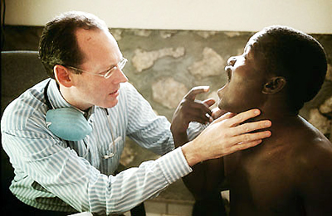
- The title of the book comes from the Haitian proverb, “beyond mountains there are mountains.” What does the saying mean in the context of the culture it comes from, and what does it mean in relation to Farmer’s work? Can you think of other situations—personal or societal—for which this proverb might be apt? Explain.
Wherever Paul Farmer goes to help cure the sick, there was always somewhere else that needed just as much help. For every mountain he was traveling, there were more mountains that needed his attention. In the grand scheme of things, he was willing to travel and take on big projects. He was willing to conquer the different mountains. I don’t particularly think that a person has all the control in this situation, but certainly has some way of affecting the outcome.
A personal example for me would be that lately, I have had some bad fortune. Almost two weeks ago, I got in a car accident. Following that, my boyfriend’s car stopped working because the battery died. To every problem we have, there are more problems. In the grand scheme of life though, others always have it worse. I have seen more car wrecks this week than ever that were far worse and hurtful than the one I go in. I have to be thankful that I can still travel those mountains. In society, there will always be subjects that seem to be able to be tackled, but will never actually get to that perfect point.
Five Major Lessons
  - Remain attentive to the cultures around you.
  - Keep in mind the religious and social aspects of a society.
  - Wherever there is a will, there is a way.
  - One person can make a difference.
  - Never give up on something that means the world to you.
Perspectives on How You See the World
I definitely think that traveling for a cause is great, like voluntourism. I do want to first and foremost travel. I would like to immerse myself in others cultures and help those that I can. But on the other hand, I want to increase my knowledge of the world and have other cultures teach me. There is no right way of living in this world. I have a broader perspective on traveling now. I would like to travel not just for leisure, but for a cultural perspective. I am also always up for adventure and healthy living. I love going camping and staying in places where I can hike, bike, run, and enjoy nature while staying fit. I think this is a trend that many individuals are partaking in.

Section #4: Midterm Online Survey

I have completed the survey online according to the directions in our portfolio assignment. I know it will be anonymous and is not submitted in this portfolio.

Section #5: Project Implicit
Interpretation of the Results
I think it is interesting how the results worked for the five different tests. I did not particularity like how the questions were asked over and over again. I got frustrated and had to come back to the tests a few times. I think this is because I felt like I was answering the same questions over and over again and that the test was trying to trick me. I kept messing up on which key to press. Needless to say, I got through it. In my first test, Gender-Science, I scored high male to science and female to liberal rights. I think that this is true in society, but I do think women can do just as well in science as well as men do just as well in liberal arts. I am in the hospitality major and we do many things that people consider the liberal arts and it is mostly women in my major. I also have seen many girls in the sciences though. For example, I know three girls from my sorority are in the engineering major. It is bad to associate a gender to science I believe. Our world seems to be getting a lot better at being gender neutral, but there will always be that stigma on girls or guys being a particular way and going in a certain direction. In my test on preference to light or dark skin, I scored a moderate preference to light skin. I am not racist in any form. I think I scored this way because many times I have had all dark skin tables while waitressing and 95% of the time the time they do not tip. I don’t know if this is bad luck or just the type of clientele that comes in but it really frustrates me. I am in no way racist! Just get a little frustrated in situations like this. In Orange County, there was an area with a high population of Mexican students, and they were known for causing trouble and being less inclined to actually attend school and do well. My mom would not allow me to go there just for the fact of what the rumors are. I have many friends who are Mexican that have done well, but there are facts that prove some areas are less fortunate or turn out to be a certain way. On the weapons survey I scored higher for African American’s with weapons. I truly have no opinion on this topic. I think both African American’s and White American’s should hold a weapon if needed and use only in emergency. Next, I scored Native Americans to be more foreign. Throughout this class I have realized that Native Americans were actually the main components to lands in America and they have been mistreated. I learned this is in my history class as well. It is not fair to think of them as foreign. They have worked hard through civilization. I would say they worked harder than Europeans and white Americans. Lastly, I took the test on think vs fat people. I do have an active lifestyle and a preference to be around thin people. I don’t know if I would call it thin though. I like being around individuals who like to stay active, eat healthy, and stay in shape. I believe it is possible to be healthy in all sorts of ways. I feel as though these types of people are more inclined to do well in life.

Relevance to Cultural Diversity
This entire assignment shows that there are different stigmas placed on groups of people. It is important to see this world as culturally diverse. All groups have a capability to do well in this world. Learning about the past to do well in the future is key as well. We can take the way Native Americans have fought for their land, we can take away the ways blacks were mistreated, and we can use this information to create a culturally diverse society. Having respect for different cultures in our society helps us to learn and grow. We have diverse cultures just here in San Diego. We have a China Town that has spectacular Chinese food, we have particular groups just on campus like the African American Women Society where they speak about remembering their past and their accomplishments. This is just a couple to name. Overall, we may have a view but being culturally diverse will allow us to learn about different perspectives. If I travel, I want to learn about the ways of different cultures and how they learned to be that way and why they are practicing something in that way.
Relevance to Cross-Cultural Perspective
Relating to the way there are diverse cultures, a cross-cultural perspective is having ways to relate in communication, culture and travel. When you travel, you need to make sure you are reading up on the cultures and societies of the area. Knowing that a hand shake means something in one culture and could mean something bad in another is important. Sometimes a thumbs up means great job and sometimes it means you are flipping the bird. Also, communicating in a positive way to get a message across and so the people are on the same page is necessary. Understanding that your culture and another culture may not agree but deciding on respecting the area is important. You may end up in trouble if you do not follow the cultural perspective of the area. The views and traditions of a culture are often sacred and extremely important to them, so knowing how to respect the feelings of these is important. Relating back to Manzanar, and the PBS stories, many cultures felt as if they did nothing to deserve abuse or mistreatment, but they have forgiven over time. All they ask is that you review what has happened over time and to make sure it does not happen again. The past is part of who we are. Passing traditions down is very important to many cultures. We can move in a positive direction for the future if we take gender, culture, traditions, race, and attitudes into consideration and work together to understand them.
5 Test Results
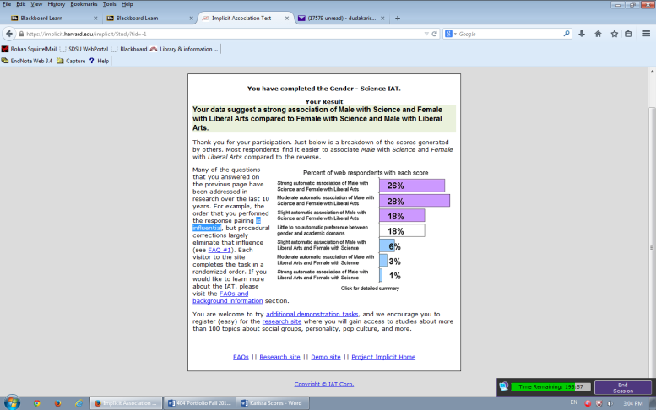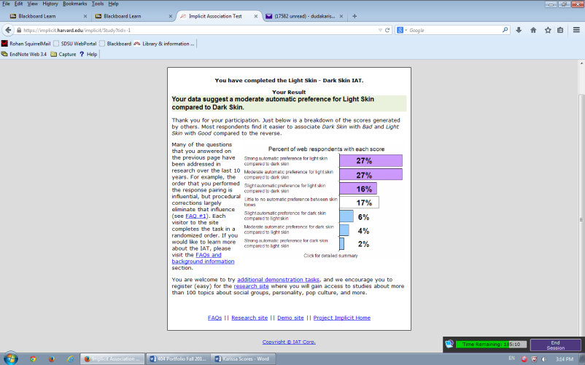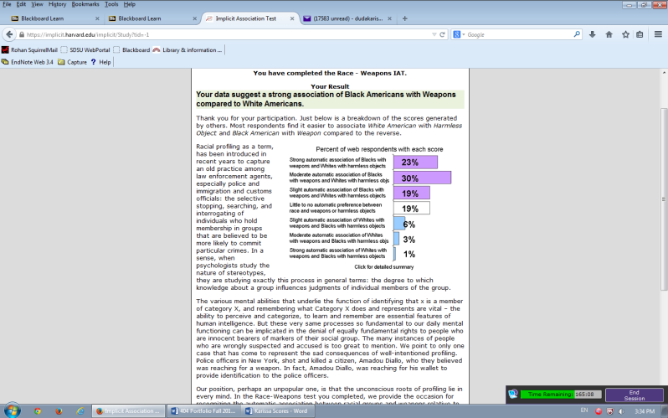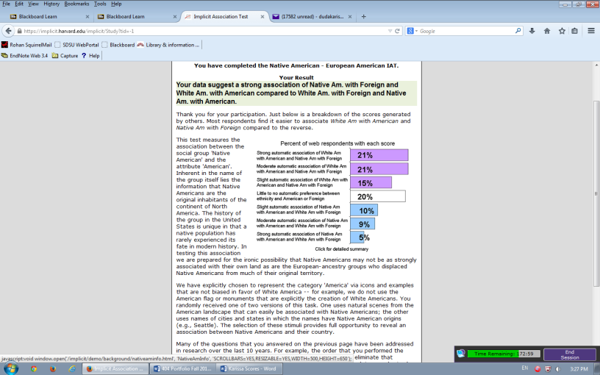
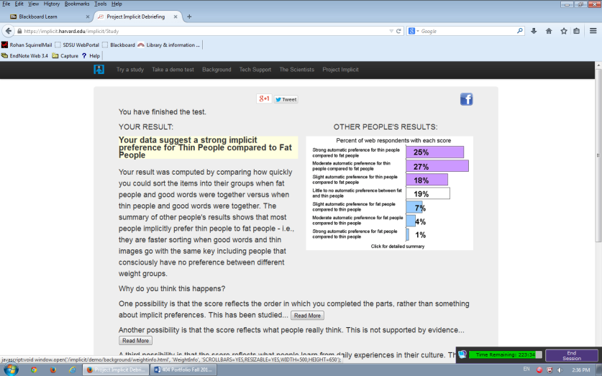

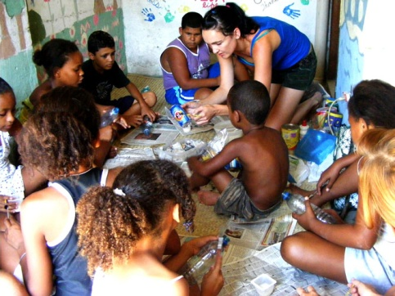
Section #6: VolunTourism
The Difficult Question:
Question #1: What is my personal minimum requirement for accommodations? I need clean water, a roof over my head, unless it is safe outside sleeping, a bed to myself, and no dangerous animals around while sleeping.
Question #2: How much money can I truly spend to pay for a VolunTourism trip? $2000
Question #3: How much time/percentage of my trip do I want to dedicate to volunteering and how much to travel & tourism? I would do a 50/50 spread for volunteering and tourism.
Question #4: How sensitive am I to deprivation, poverty, starvation, health issues, etc.? (For example, can I mentally and emotionally process being with children who have no arms or legs, or cleft palates, or bloated stomachs from malnutrition?) I might find it extremely sad and get upset, I think I would like to help them anyway I could though. I would prefer to go on a trip and see this in person actually.
Question #5: What tolerance do I have for extremes in climate? (For example, is desert heat an issue for me? Arctic cold? Rainforest humidity?) As long as I am safe, I will be fine! I would like to have some type of warmth though. I get kind of upset when it is cold.
Question #6: What food preferences and aversions do I have? (For example, can I eat anything that is placed in front of me? Vegetarian only? Food allergies?) I have no food allergies, as well as I love to try new foods. I think eating would be a huge part of my trip. I would love to try new foods in a different culture.
Question #7: How good are my people skills in relation to travel? (For example, do I feel comfortable speaking with anyone, anywhere, regardless of who it may be? Only people I know? Do I like to travel alone?) I do not speak any other languages, but I love talking to different types of people. I would prefer to travel with someone I know.
Question #8: What travel experience do I have? (Domestic? International? None?) I have only gone dirtbiking, camping in California, nature hiking, and to a few states. Nothing international or abroad yet!
Question #9: What volunteer experience do I have? I went on a mission trip before, as well as helped the homeless.
Question #10: What voluntary service would I like to perform? I would like to help with water, housing, clothing, anything to really help the well being of a community.

Insights about Trip Preparation:
1. Read about the cultural taboos of where you are going.
2. Shift your attitude regarding time. Be more "agricultural-based".
3. Get travelers insurance
Processing Experiences
I think that it is beneficial to travelers to think about how they will spend their free time and how they will deal with life’s challenges. A lot of travelers under voluntourism especially will see things that are out of the ordinary and tough from their everyday lives. I think the advice is clear and helps set up what a volunteer tourist is about to go through. Below I have presented three insights based on the advice this section gives.
- Take in to account that the normal lives of other countries may be very difficult to bare. This includes seeing malnutrition, poverty, and severe weather conditions.
- Determine the type of free time you prefer. (EX: Group or individual time)
- Does the Voluntourism trip provide a sufficient time and activity that you enjoy?
  - Walking, jogging, yoga
  - Contemplative silence
  - Group talks
  - Prayer

Post-trip
This section is particularly odd to me. I am not sure if I agree with this section. I guess I have not done a full on voluntourism trip so I would have to see after I do, but I think it would be helpful to talk and share stories after you are back. You might want to share how thankful you are to live the life you lead. The post-trip paragraphs said to avoid the story telling. I don’t like that it says that. Below are insights I gained on the post-trip section.
- Find your motivation to do something to further support work you did on your trip.
- Keep in contact with your fellow travelers to support re-entry into your “Home”.
- Do invite friends to learn about your trip.
Summary of Articles
The Events that Shaped and Influenced Voluntourism in Decade 1.0
The author spoke about different events, both internal and external, that have led to a rise and a sort of conversation for the Voluntourism industry. He starts with September 11th 2001 and how it awakened a new commitment to service. The horrific incidence created a consciousness to humanity, a new commitment to service, as well as an economic impact of tourism. Our world had to find a way to cope, and they did so with volunteer programs, security in airports, as well as driving tourism to help New York. In 2003, Tauck launded the Yellowstone Guest Volunteer Program that accumulated 10,000 volunteers over 6 years. This program of corporate responsibility has continued in to other parks. These two turning points have addressed the beginning of Voluntourism.
To go into more depth, magazines, natural disaster, and even hotels have led to a form of more new good habits. Voluntourism is still a newer idea that will keep evolving but seems to be in a good place. To continue on with the events, in 2004 Travel and Leisure Magazine opened the door for the use of the work “voluntourism”. Many more blogs, magazines, news publishing, and articles started to state the word in public. Also in 2004, the Asian Tsunami engaged an unorganized volunteer system. In 2005 Hurricane Katrina got the travel and tourism industry involved with collaboration with nonprofit organizations through service projects. Since 2005 when Katrina happened, there has been meetings and conventions to be held on the topic of voluntourism alone. Skipping to 2006, the initiative of travel for good was made and then in 2008 Ritz Carlton initiated the “give Back Getaways” programs. It stirred up a large commotion but did lead to conversation. This leads me to my thought that conversation, good or bad is publicity, so it will help in voluntourism.
Voluntourism 2020 Vision
For the 2020 Vision, Clemmons will be traveling to Jordan to create a vision for voluntourism. Their idea is to take the 1.6 billion people that are engaged in tourism and take 10 percent of them and engage them in voluntourism. That is their estimated number of followers. They have a plan of first, creating a destination specific voluntourism web portal and then second, The dragonfly effect. To take these two into fruition they are enlisting the assistance of academics, tourist professionals, NGOs, travelers, and community residents. They will take the variety of viewpoints to make the web portal and take the dragonfly effect to the next step.
The webportal will present bookings, predetermined opportunities for traveling and service options. The webportal will provide a less challenging decision making process as well as an easy access to voluntourism. The makers will use communication and collaboration to make sure the voluntourism initiative unfolds.
The Dragonfly Effect will direct traffic to a specific location and will cross-promote the ideas of the web portal and voluntourism. The first wing means they need to identify a single concrete measurable goal. Wing two is cut through noise of social media with something authentic and memorable. Wing three is get the target market emotionally involved. The last wing, wing number four is spur our audience to work on behalf of the cause.
Wisdom and Insight: Brain Fitness, Cognitive Health and VolunTourism
This essay gave insights from Alvaro Fernandez and how our cognitive health is pertinent to our traveling and VolunTourism pathways. He says that there are new habits that alter our paths. VolunTourism experiences serve to assist voluntourists in exploring their own brain fitness and cognitive health. He noted that there are exercises that we can do to re-train the human brain. This is positive for the future of our studies, health, and discoveries.
The essay uses the word Neuroplasticity to explain that there are differing views on just the definition of words. Fernandez explains that how we explain our choices of words has an impact. We need to learn to do new things, not just more of the same thing. For example we should learn a new language, a new skill, or a new ability. When we pay attention more and process our environment in the beginning and then take care of the emotional self-regulation to manage stress and anxiety of being exposed to new contacts then we are being mindful to our cognitive health.
To relate this idea to VolunTourism, we learned about the W curve and how we must deal with getting back in to our everyday life at “home”. When we have a healthy cognitive health, then we could manage the stress and anxiety of settling back in to our real world. Other parts of the world may eat off five cents, but then we are making extra food that we dump down the drain. How we deal with setting back in and how we use our experiences to direct activities positively related to our cognitive health.
Have we Reached the Age of the “Transformation Economy”?
There is a relationship between experiencing and transforming. I have learned about the transformation theory in my HTM courses, but what is beneficial to take away from this article is that there is an elicitor/guide and then there is an aspirant that have intangible duties in VolunTourism. The Transformation Economy is just that. You have to feel a certain way and come out of your trip being changed with just something that occurred that is intangible.
An experience economy uses services and goods to engage customers, so it will be a memorable event. Voluntourism is a collaboration between voluntary service and tourist engagement. People don’t tend to just sit back when they travel anymore. They want a personal change that again is intangible. The aspirant has to feel that they have gotten what they wanted whether it be peace of mind, a thrill, a new aspect of thinking, or just that experience of a lifetime, the elicitor has to create the ways of transforming the individual.
Polluck is quoted in this article saying that there are aspects of transaction that are:
- Correct diagnosis of need
- Development of a shared agreement regarding aspirations
- Support and guidance to breakthrough
- Sustained, long-term follow through
The different aspects will guide ways into creating a transformation for the voluntourist.
Here Comes the Sun
Larry Beck describes his Voluntourism trip to Maccu Picchu but relates it to the way all voluntourisms can experience. He says that you choose a destination that has the adventure you want and then split your trip up into a meaningful way to yourself personally. The Organization that you are traveling for should resonate with your own values and beliefs. Beck loved the Globe organization because it did just what their mission states, “help people, have fun”. He also spoke about fellow travelers under voluntourism. He says that they are easy to get along with. They are trusting, patient, adventurous, joyful, and emotional. When he said emotional he means that you can show compassion for the people of the country you are visiting and you have a heart. The place where you are staying is going to be different than what you are used to.
When describing the place he was volunteering at, Beck noted the food, bathrooms, shelter, people, altitude, weather, and schools were all different than what he was used to. The different sights that the people of Maccu Picchu brought them to were sacred and recognizing the Winter Solstice, but to us it looked like a big concert and firework show. The work projects within the visit were tough but worth it. Kids just wanted to play all night. During physical labor, they were often give non-useful tools, but Beck and his fellow traveler figured out a way to help. The people of Maccu Picchu were happy with little. In the end, there is a mutual relationship and both the host and the traveler benefit immensely. We can choose to be participants, not just observers in the universe.
VolunTourism for you?
I would love to partake in a Voluntourism trip. I think it is a beneficial way to travel while being part of something bigger than myself. I would love to learn about the cultures of others while they are learning about me. I want to test my normal ways of doing things. I would love to play soccer with little kids and see them smile. I think it would be very hard to do the physical labor of building houses or sewage drains, but I know it would be worth it in the end. Having that mutual benefit would be rewarding.
I am someone who loves to travel and experience something at the same time. I am all about the experience economy as one of the articles mentioned. I don’t want to sit back and just watch, I want to go play and have some fun! I think Voluntourism is a way of having fun, working hard, and gaining so much more knowledge than you arrived with. When I have some extra money, I will make my decision on where to go and start planning a Voluntourism trip.
Section 7 Final Online Survey
I will take my online survey upon the completion of my final. I have learned so much in this class and will use my gained knowledge to choose how and where I will travel.

Table of Contents
Section 1: PBS Untold Stories Project
Yosemite Buffalo Soldiers
Mount Rushmore, Telling America’s Stories
Manzanar, Never Again
Section 2: Codes of Cultural Behavior
Choice of Country
Brief Cultural Overview
Codes of Cultural Behavior (Dos and Don’ts)
Unusual Aspects of Culture
Section 3: Mountains Beyond Mountains Essays
Application of the W Curve of Cultural Change
Connecting with People Who are Different
Beyond Mountains There are Mountains
Five Major Lessons
Perspectives on How You See the World
Section 4: Midterm Online Survey (Grade Center Check Mark)
Section 5: Project Implicit
Interpretation of Results
Relevance to Cultural Diversity
Relevance to Cross Cultural Perspectives of Tourism
Results for 5 Tests
Section 6: VolunTourism
The Difficult Questions
Insights About Trip Preparation
Processing Experiences
Post-Trip
Summary of 5 Articles
VolunTourism for You?
Section 7: Final Online Survey (Grade Center Check Mark)

